
National Textile University
Department of Computer Science
Subject:
Mobile application and development
Submitted To:
Sir Rehan Sarwar
Submitted By:
Noor ul Ain
Registration No:
23-NTU-CS-1135
Lab no:
8
Semester:
6th

Flutter Weather Fetcher App
Part 1: Setup and API Key
- Generate an API Key
- Initialize the Flutter Project
- Add Dependencies
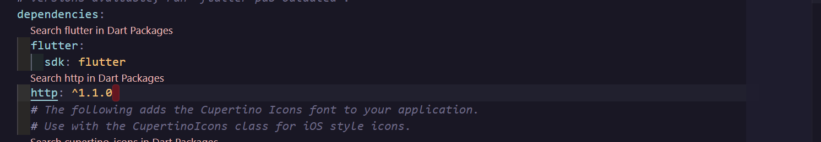
Part 2: The Data Model
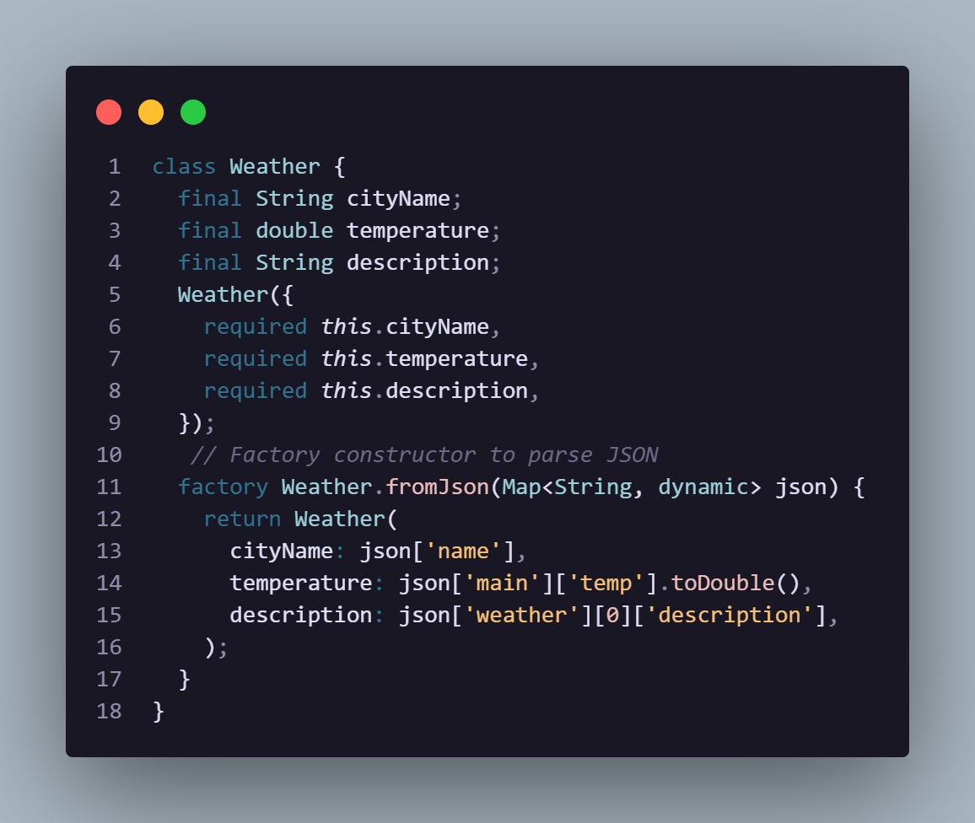
Part 3: The API Service
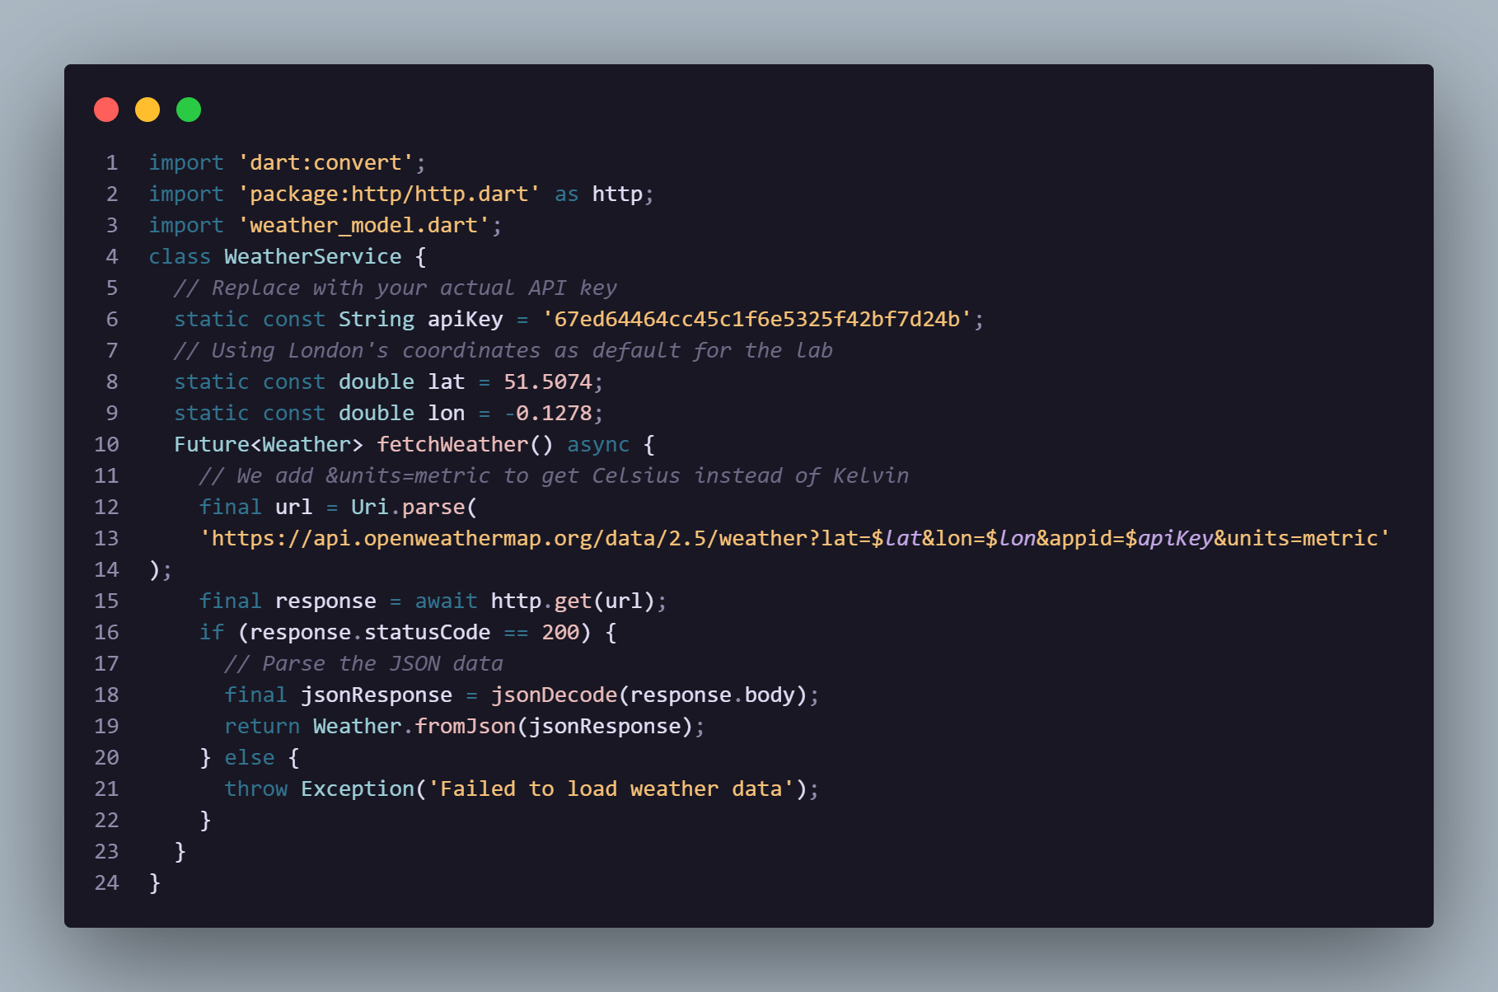
Part 4: Building the User Interface
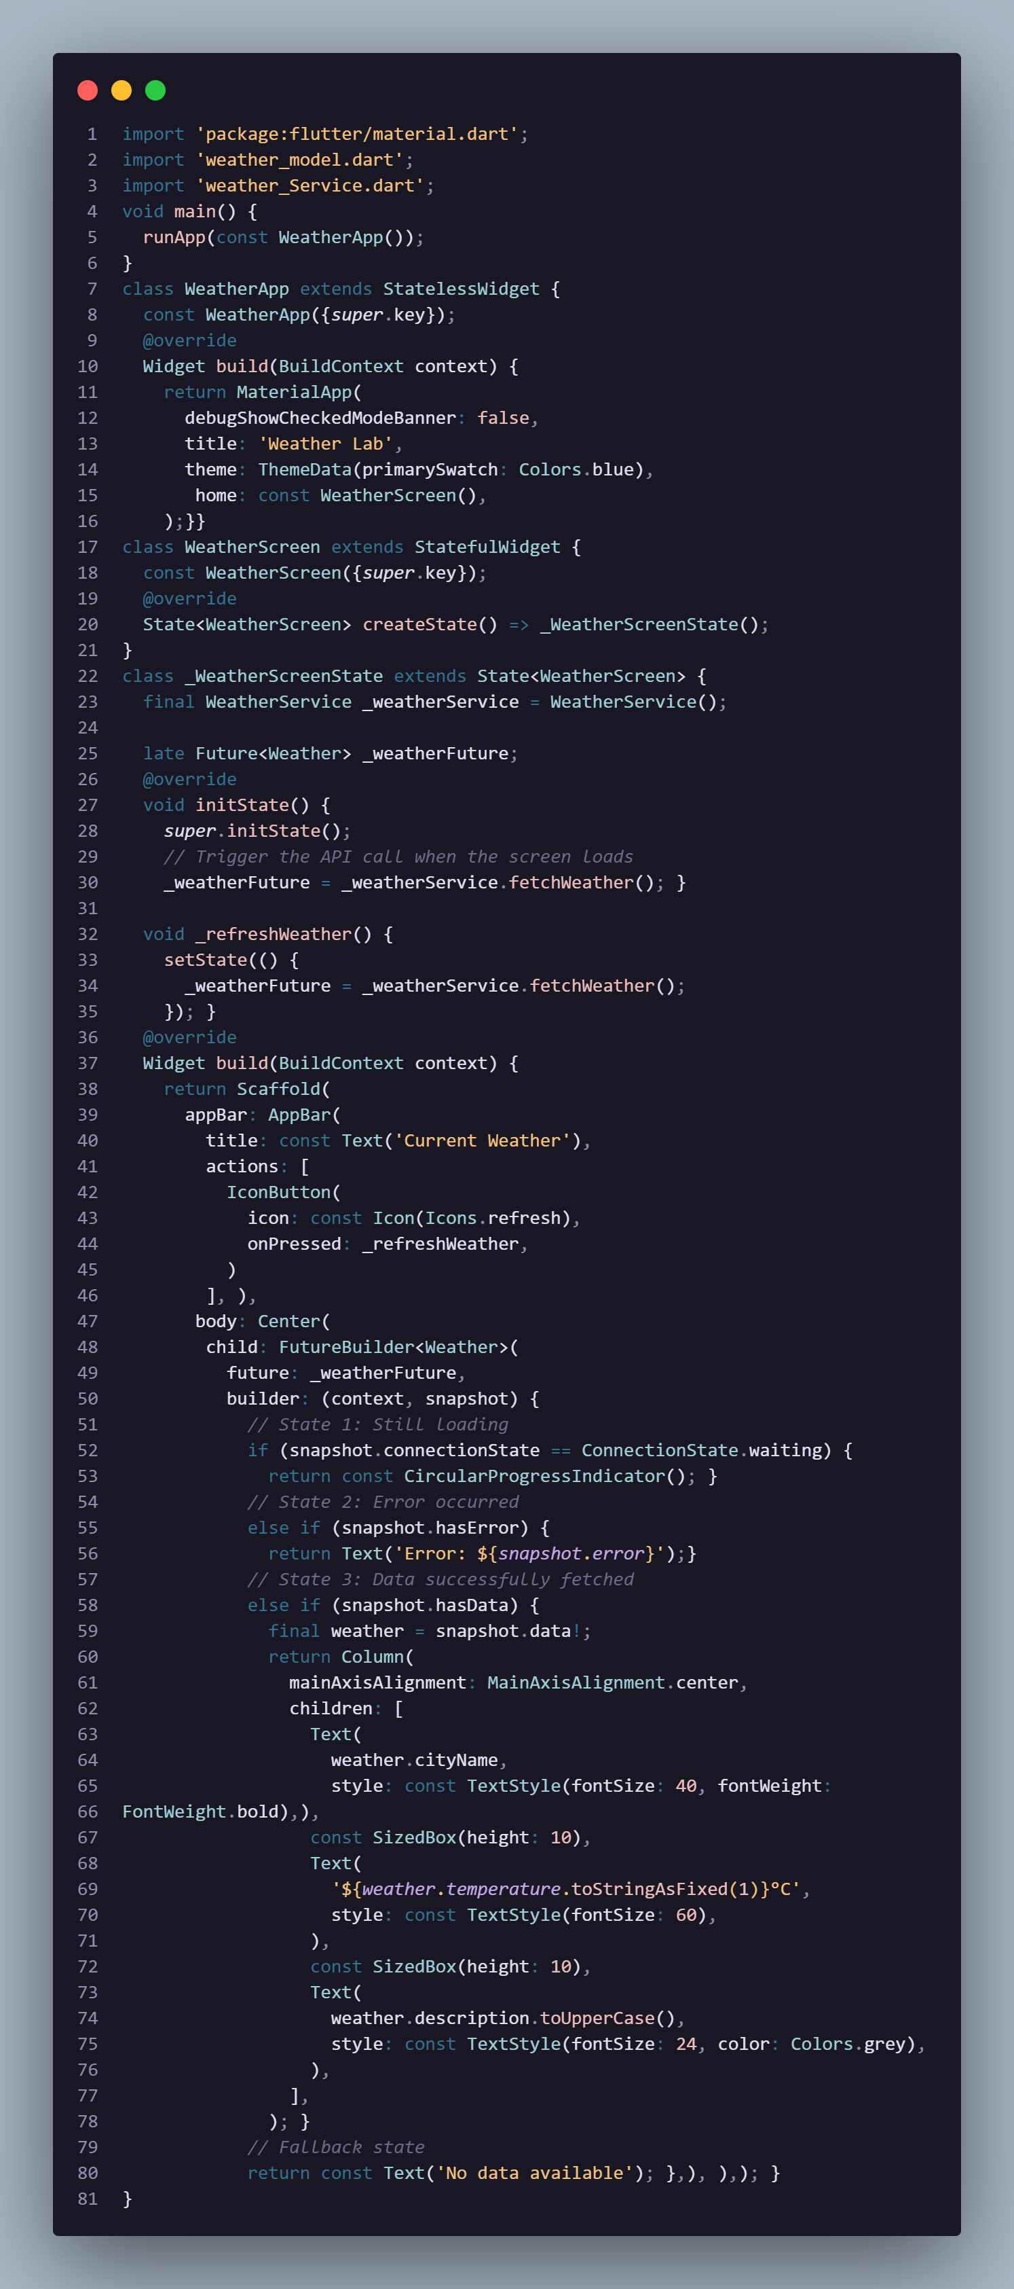
Part 5: Lab Execution & Bonus Challenges
Execution:
- Insert your actual API key into weather_service.dart
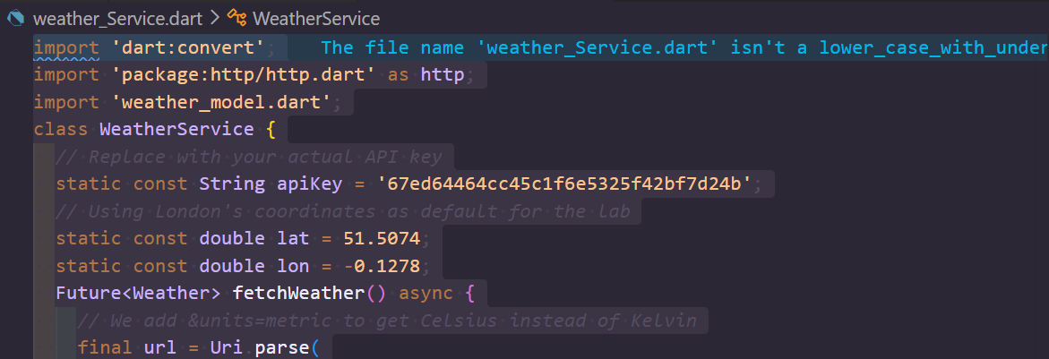
- Run the app (Flutter run).
- You should see a loading spinner briefly, followed by the current temperature, city name, and condition for London.
Output:
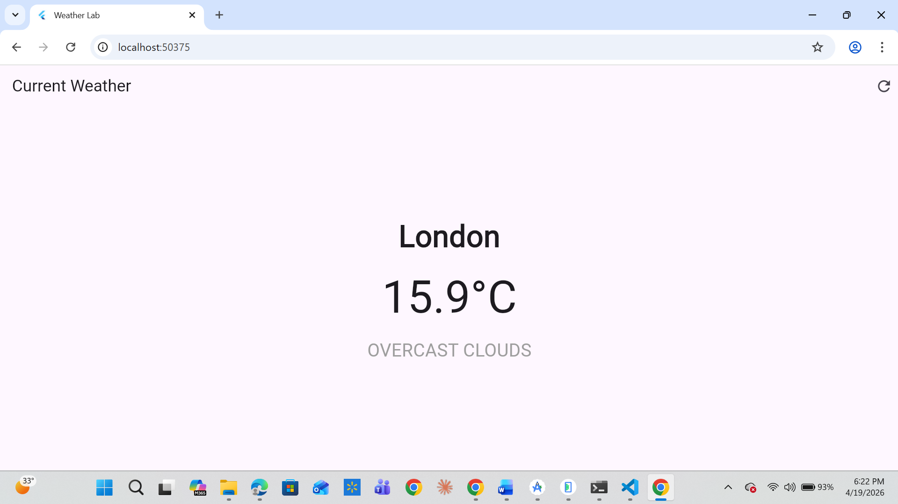

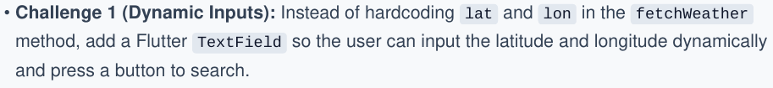
Code:
Main.dart file:
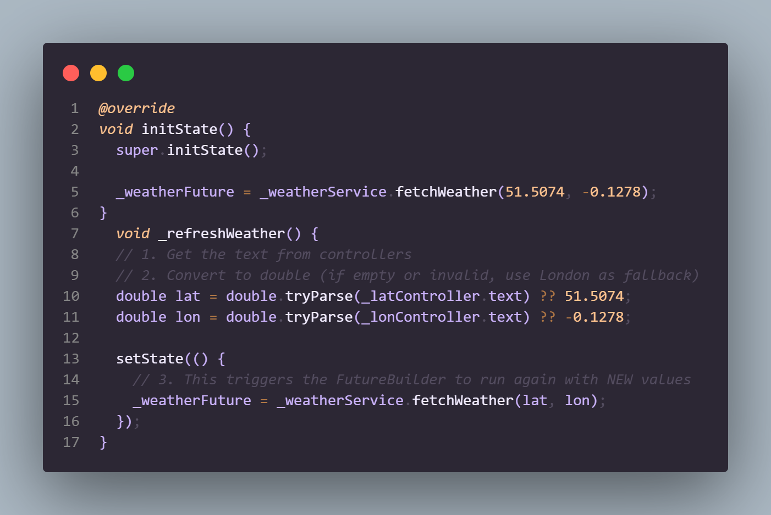
Dynamic text fields:
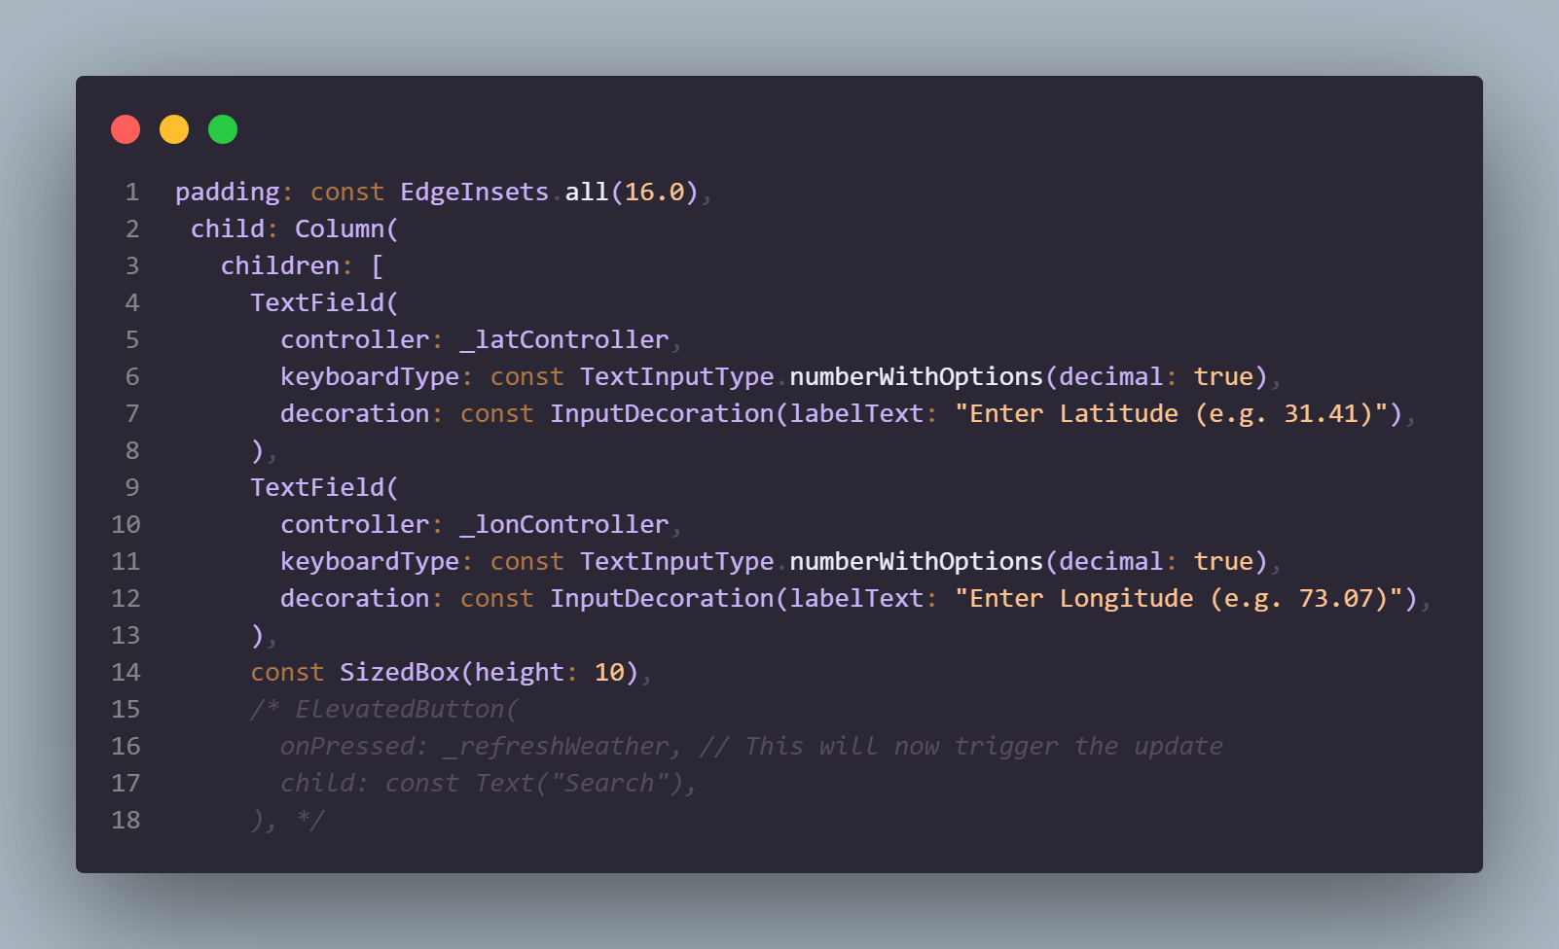
Output:
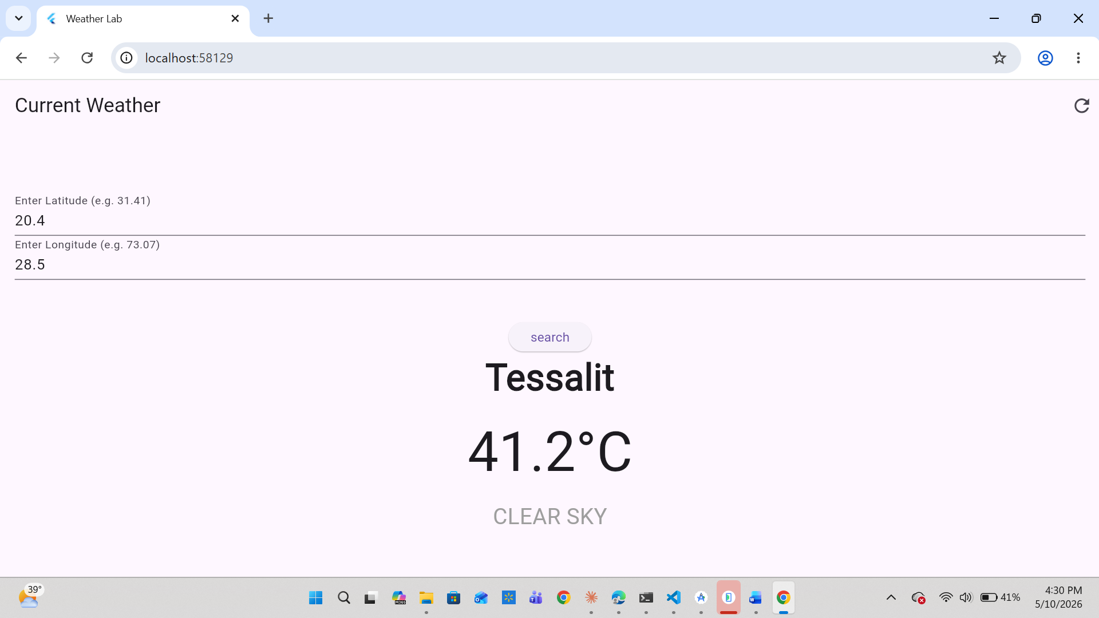

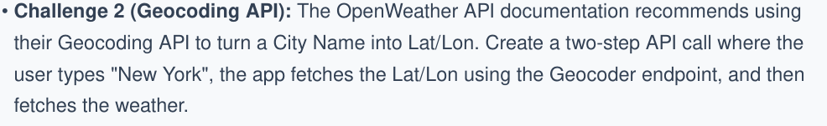
Adding function to weather_service. Dart class file:
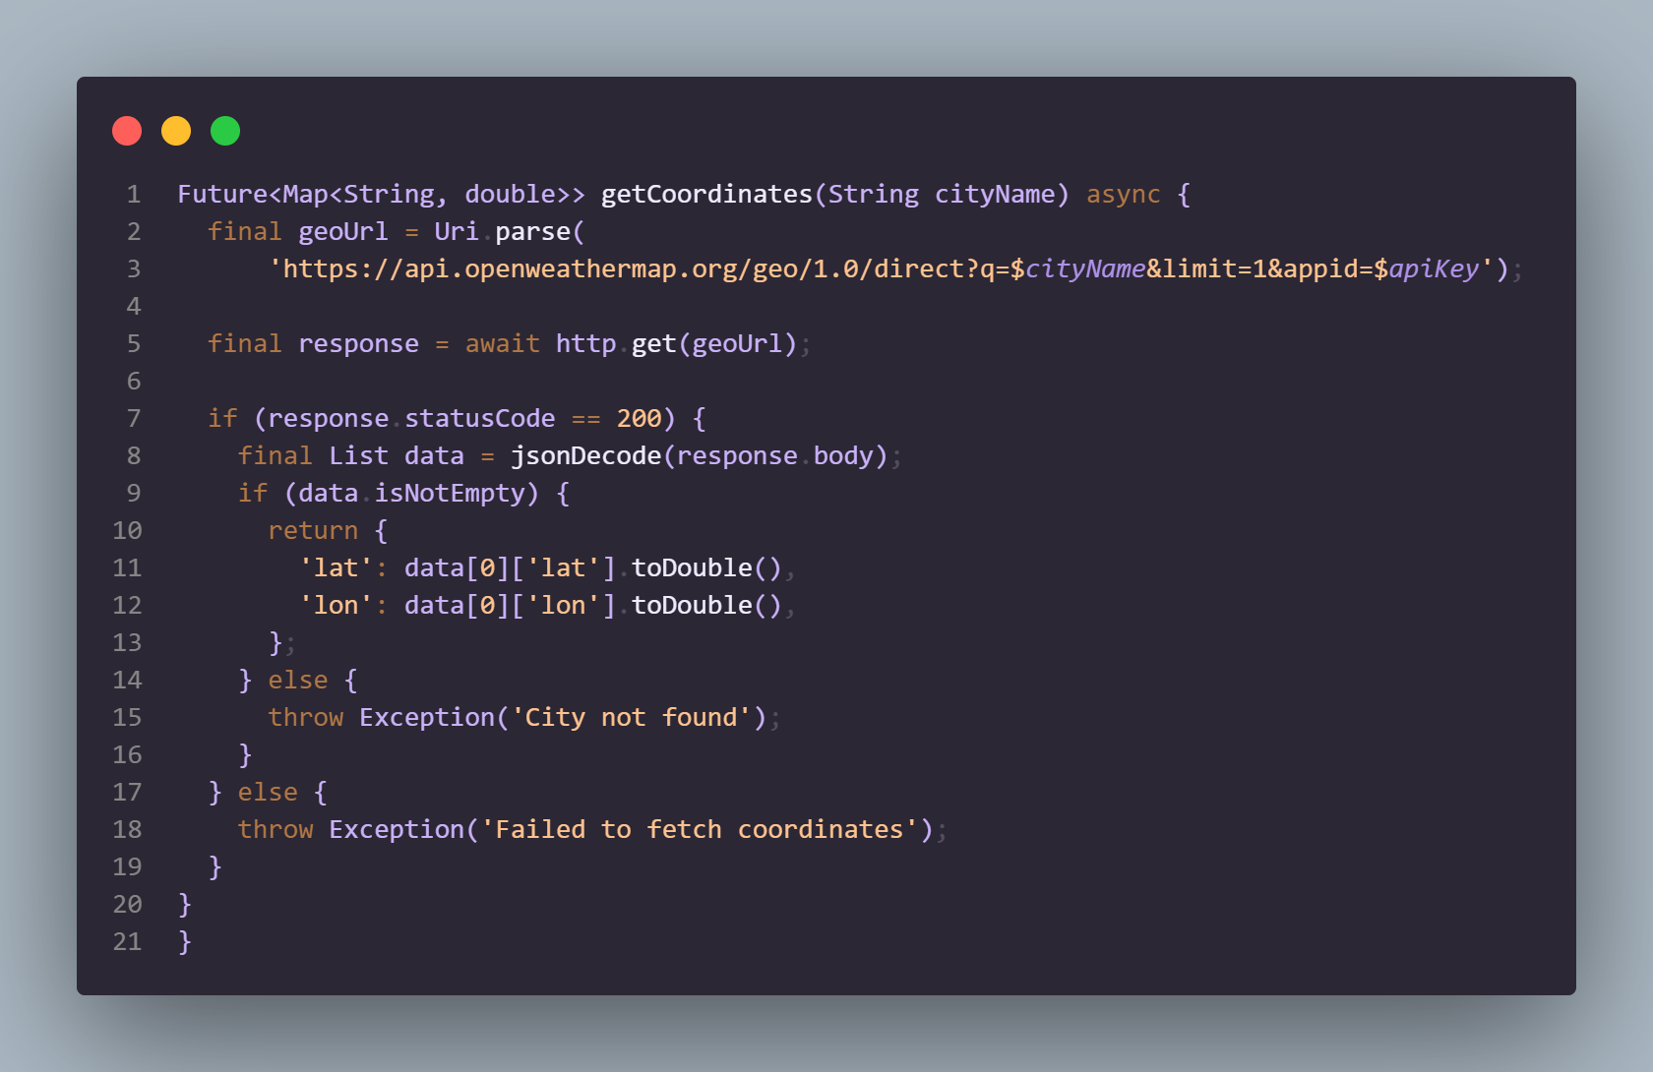

Changes in Main.dart:
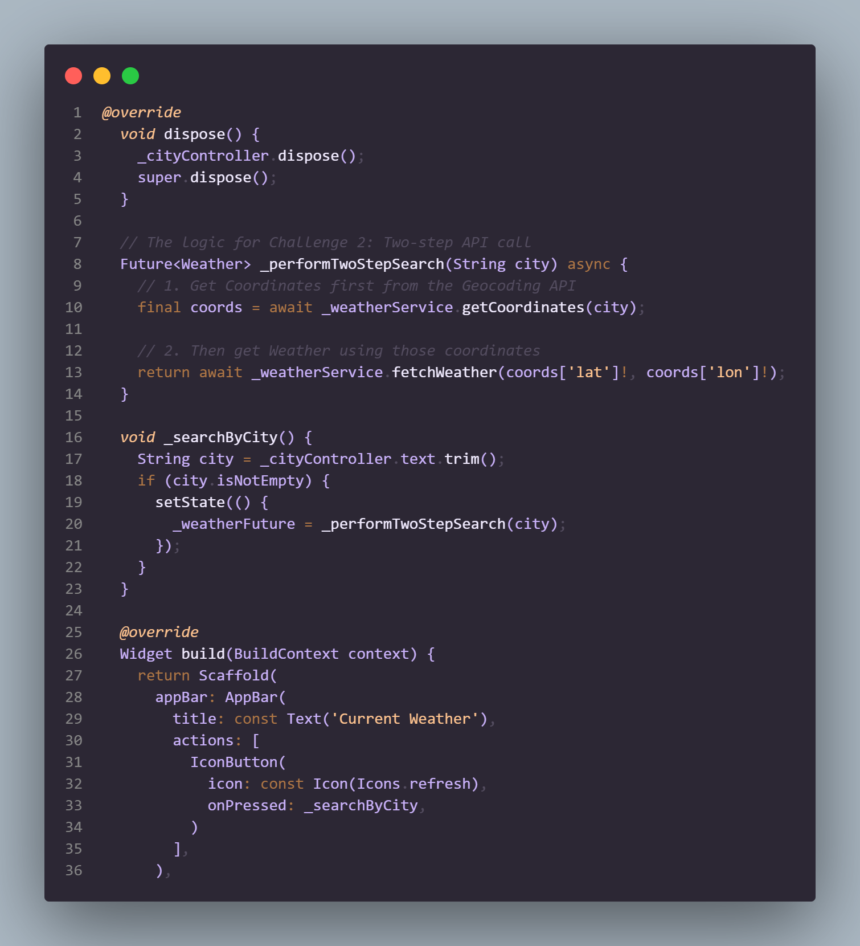

Output:
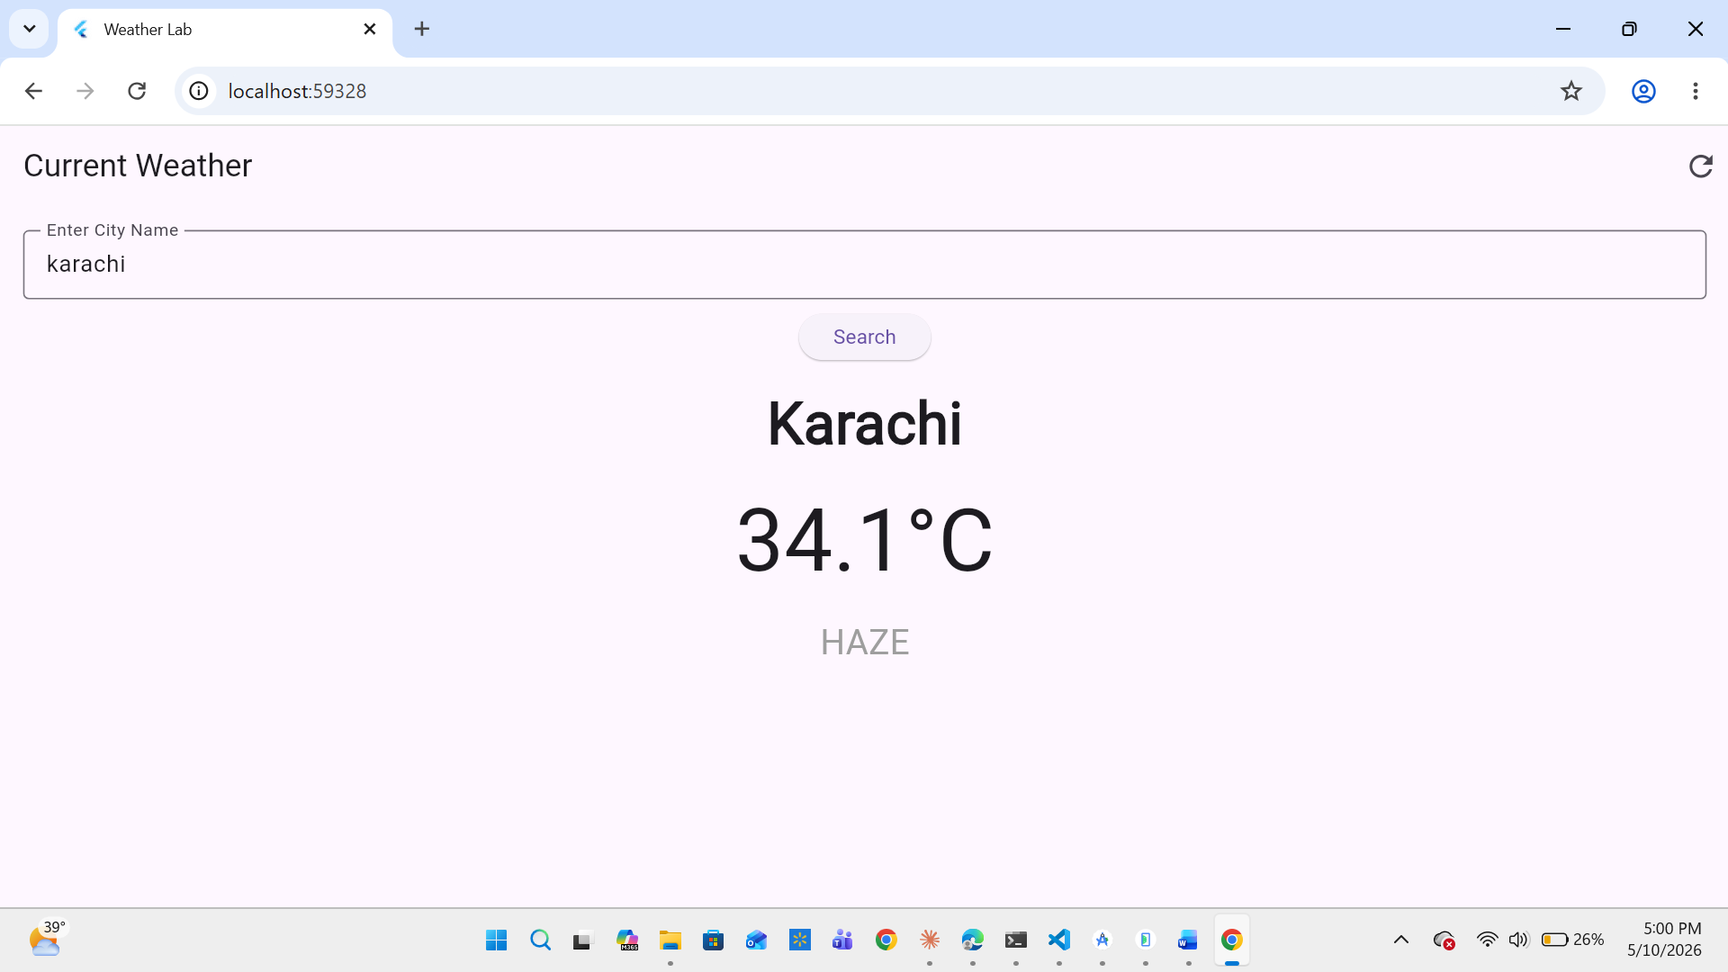

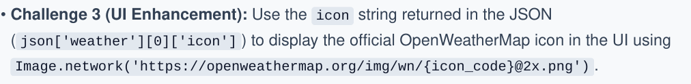Updated the model.dart file:
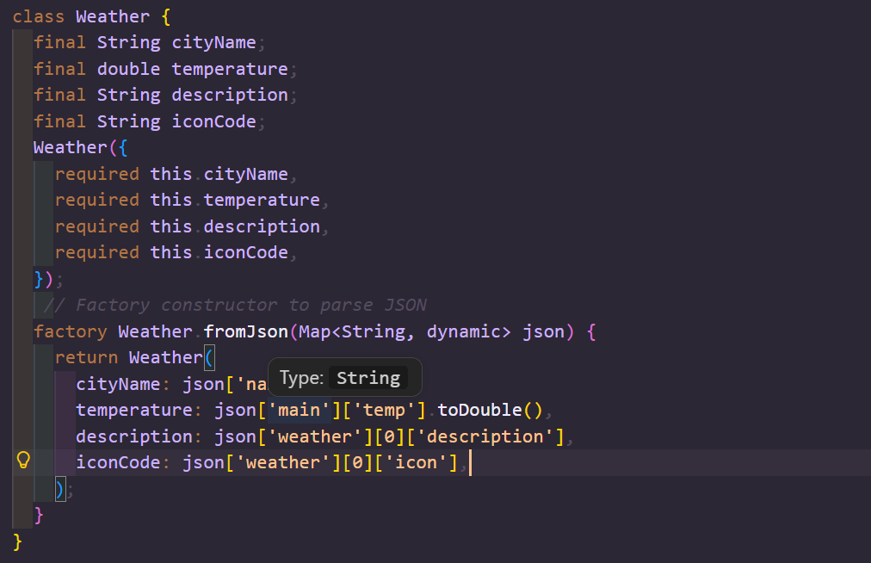
Added image network widget in column widget in main.dart file:
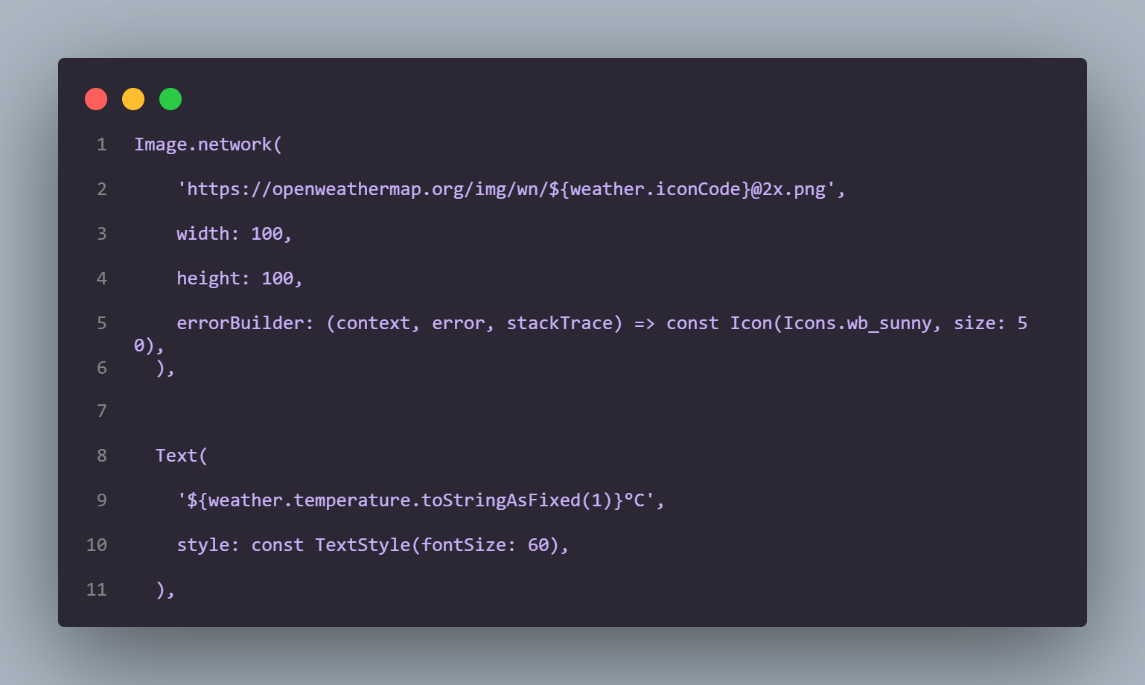
Output:
